**IE 6318 Data Mining and Analytics**

**Homework 1**

Data Exploration

2. Explore the Iris dataset and report the following:

1) 2D scatter plots of the four attributes. (In Matlab use function ‘plotmatrix’ or ‘gplotmatrix’)

***% main program for HW1***

***A =irisdata2;***

***figure(1);***

***plotmatrix(A);***

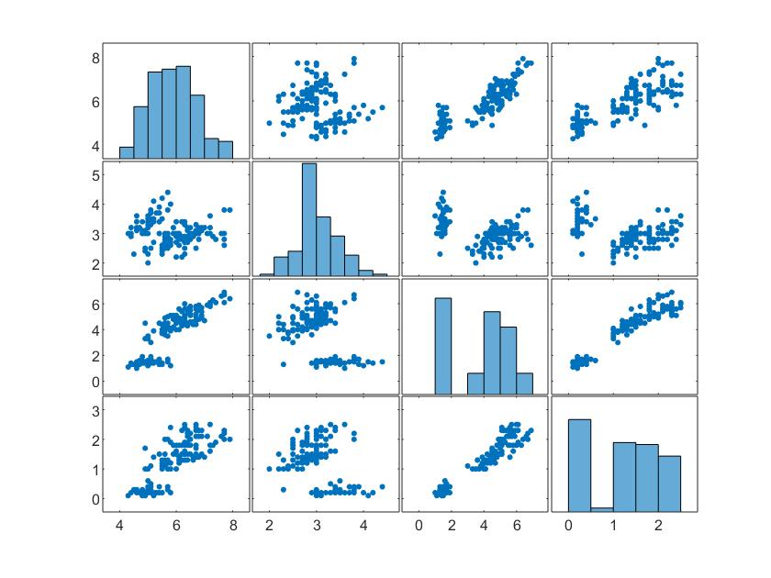

***2-D Scatter Plot of Four Attributes***

2) 3D scatter plot of three attributes (sepal length, sepal width, petal width). (In Matlab use function ‘scatter3’)

***% main program for HW1***

***A =irisdata2;***

***figure(1);***

***plotmatrix(A);***

***SepalLengthcm = A(:,1);***

***SepalWidthcm = A(:,2);***

***PetalWidthcm = A(:,4);***

***figure(2);***

***scatter3(SepalLengthcm,SepalWidthcm,PetalWidthcm);***

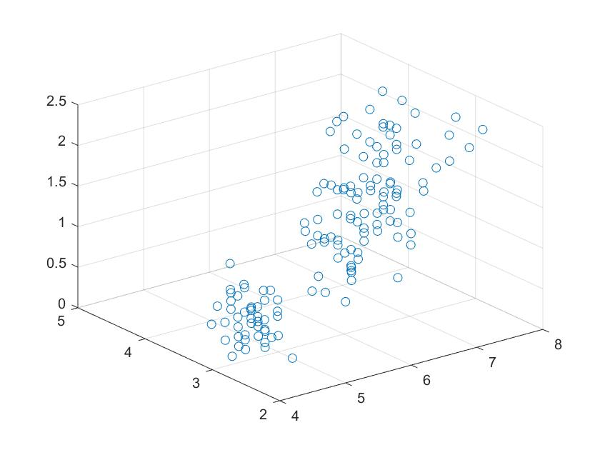

***Scatter plot 3-D for Three Attributes***

3) Visualization of the feature matrix (column 1-4). (In Matlab use function ‘imagesc’)

***A =irisdata2;***

***figure(1);***

***plotmatrix(A);***

***SepalLengthcm = A(:,1);***

***SepalWidthcm = A(:,2);***

***PetalWidthcm = A(:,4);***

***figure(2);***

***scatter3(SepalLengthcm,SepalWidthcm,PetalWidthcm);***

***figure(3);***

***imagesc(A);***

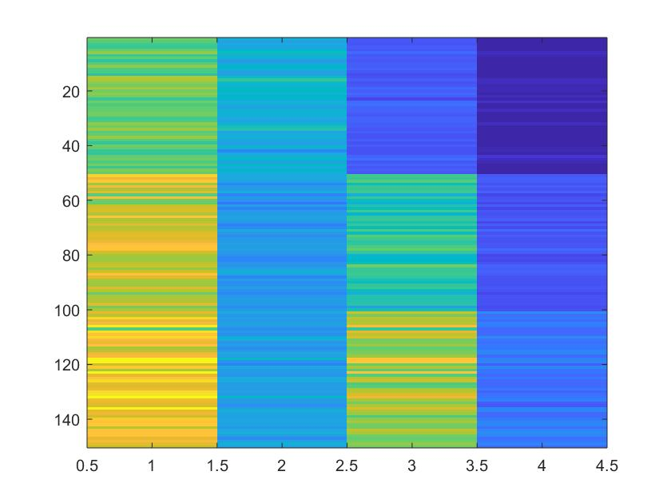

***Visualization of Feature Matrix***

4) Histogram of the four attributes for the three classes. (In Matlab use function ‘hist’)

***Class 1***

***histogram(F.SepalLengthcm);***

***hold on***

***histogram(F.SepalWidthcm);***

***hold on***

***histogram(F.PetalLengthcm);***

***hold on***

***histogram(F.PetalWidthcm);***

***>>***

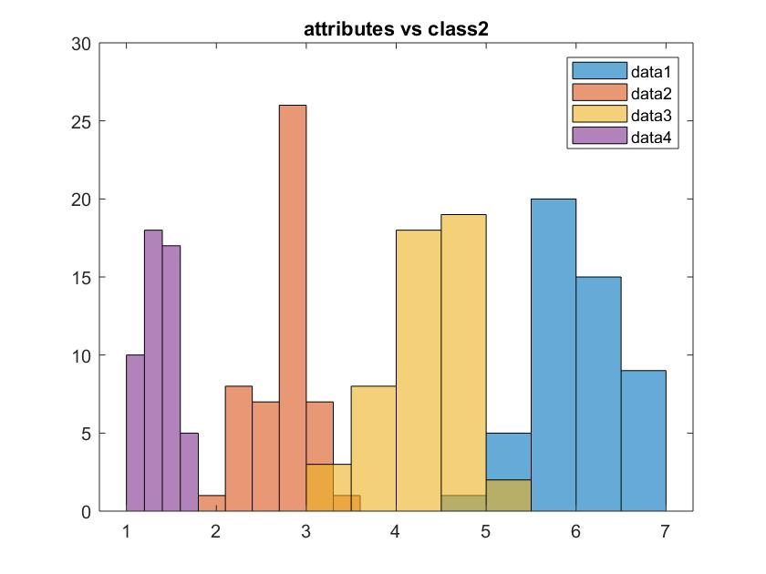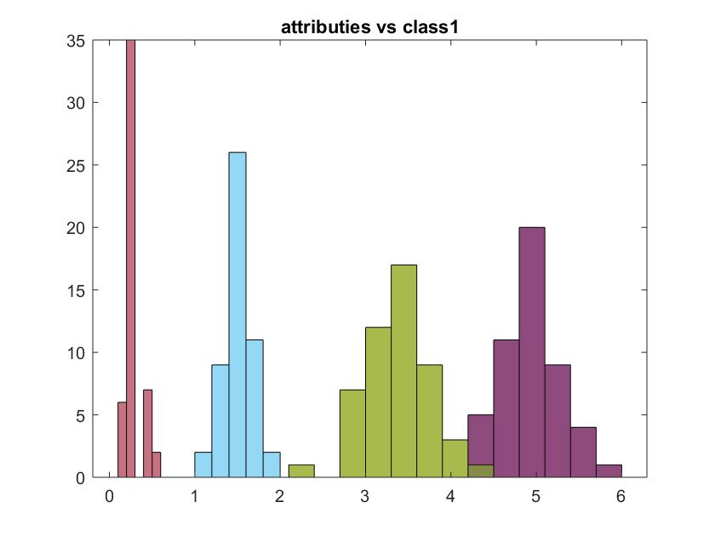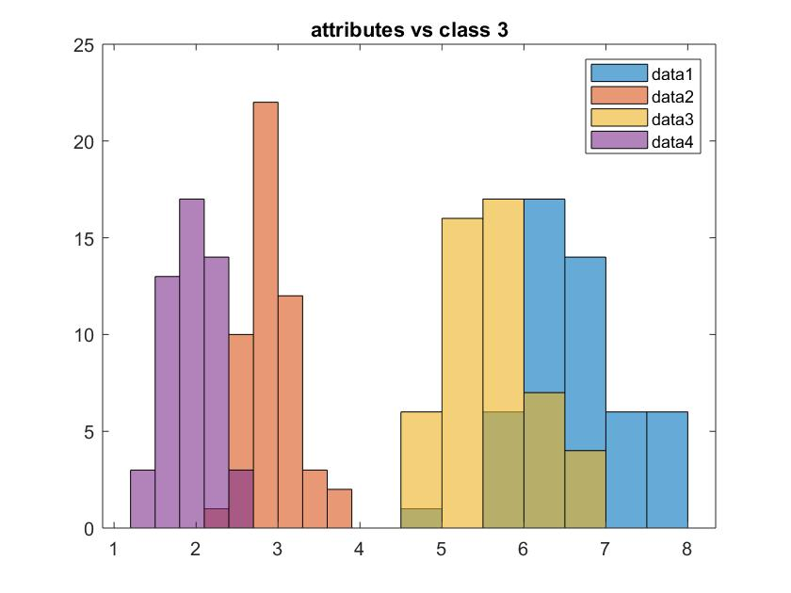

***Histograms*** ***for all the classes Class1, Class 2, Class3***

5) Boxplots of the four attributes for the three classes. (In Matlab use function ‘boxplot’)

***% main program for HW1***

***A =irisdata2;***

***figure(1);***

***plotmatrix(A);***

***SepalLengthcm = A(:,1);***

***SepalWidthcm = A(:,2);***

***PetalWidthcm = A(:,4);***

***figure(2);***

***scatter3(SepalLengthcm,SepalWidthcm,PetalWidthcm);***

***figure(3);***

***imagesc(A);***

***boxplot(SepalLengthcm,Flower);***

***boxplot(SepalWidthcm,Flower);***

***boxplot(PetalLenghtcm,Flower);***

***boxplot(Petalwidthcm,Flower);***

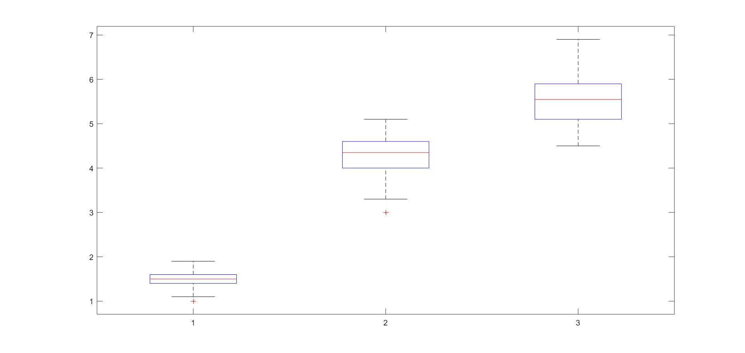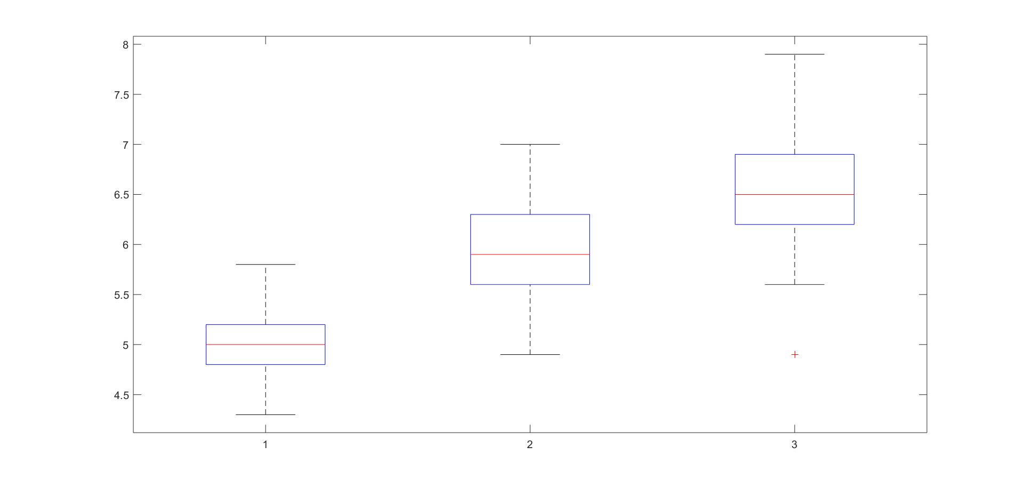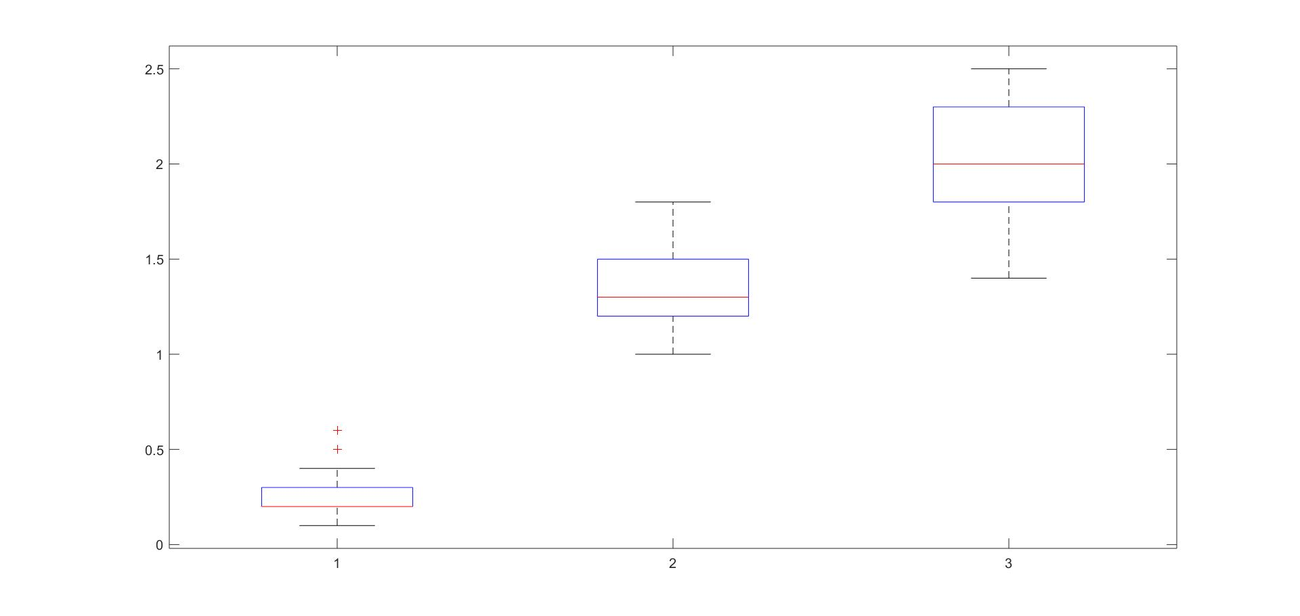

***Box plot of three classes varied according to attributes 1,2,3,4.***

6) Calculate the correlation matrix of the four attributes and visualize the correlation matrix.

***% main program for HW1***

***A =irisdata2;***

***figure(1);***

***plotmatrix(A);***

***SepalLengthcm = A(:,1);***

***SepalWidthcm = A(:,2);***

***PetalWidthcm = A(:,4);***

***figure(2);***

***scatter3(SepalLengthcm,SepalWidthcm,PetalWidthcm);***

***figure(3);***

***imagesc(A);***

***boxplot(SepalLengthcm,Flower);***

***boxplot(SepalWidthcm,Flower);***

***boxplot(PetalLenghtcm,Flower);***

***boxplot(Petalwidthcm,Flower);***

***corr(A);***

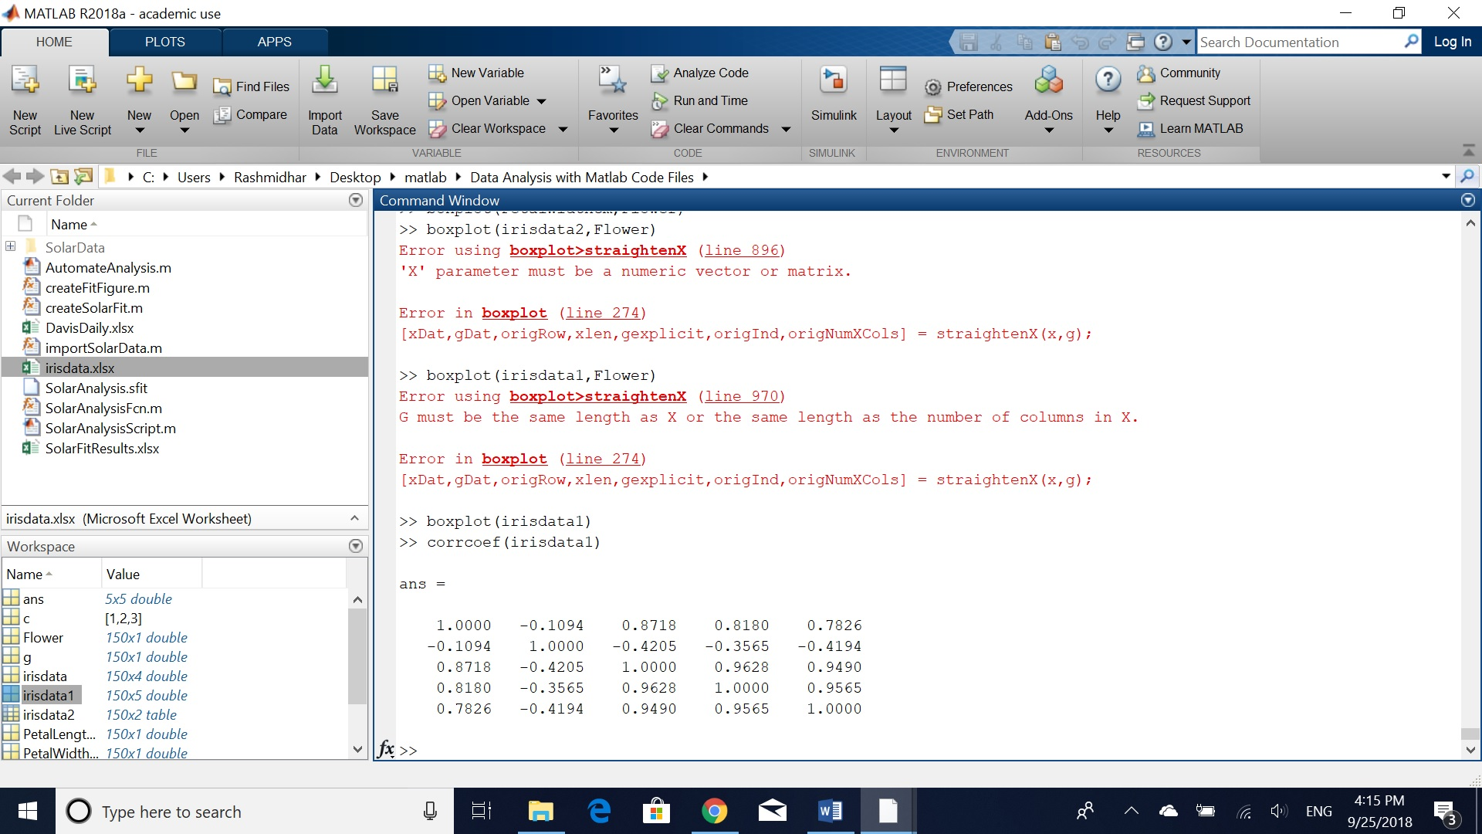

***Correlation matrix***

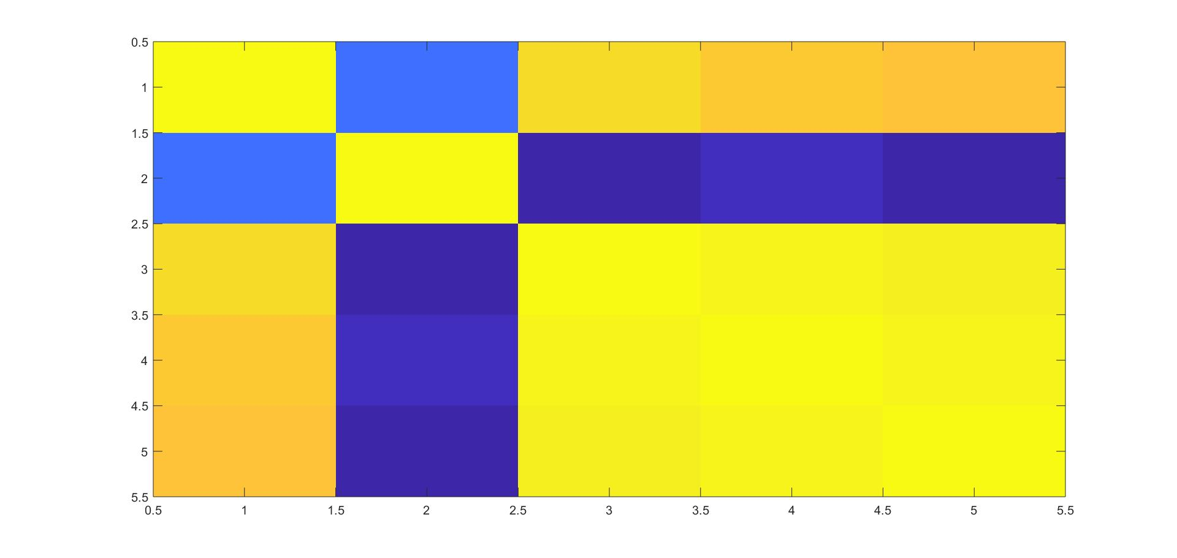

***Visualization of Correlation Matrix***

7) Parallel coordinates plot of the four attributes.

***% main program for HW1***

***A =irisdata2;***

***figure(1);***

***plotmatrix(A);***

***SepalLengthcm = A(:,1);***

***SepalWidthcm = A(:,2);***

***PetalWidthcm = A(:,4);***

***figure(2);***

***scatter3(SepalLengthcm,SepalWidthcm,PetalWidthcm);***

***figure(3);***

***imagesc(A);***

***boxplot(SepalLengthcm,Flower);***

***boxplot(SepalWidthcm,Flower);***

***boxplot(PetalLenghtcm,Flower);***

***boxplot(Petalwidthcm,Flower);***

***corr(A);***

***imagesc(ans);***

***parallelcords(A);***

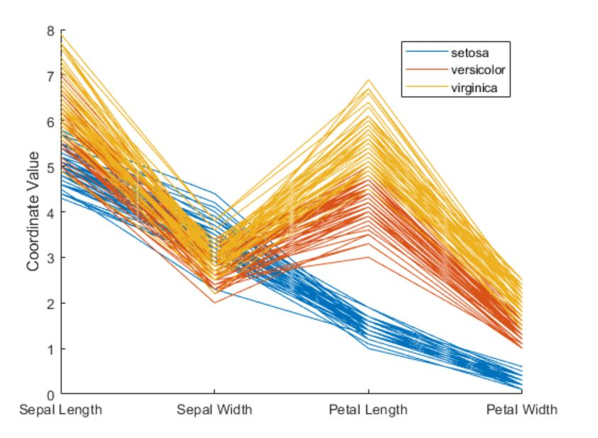

***Parallel Coordinates Plot***

3. Practice Data Distance Measures

1) Make a function for Minkowski Distance. (3 function inputs: vector A, vector B, and order r)

**function E =minko_dist(A,b,n,r)**

**p =size(A,1);**

**q =size(b,1);**

**for i=1:p**

**for j=1:q**

**for k=1:n**

**F =A(i)- b(j);**

**G =F^r;**

**H =sum(G);**

**E(i,1) =H^(1/r);**

**end**

**end**

**end**

**end**

2) Make a function for T-statistics Distance. (3 function inputs: time series A, time series B)

**function k =t_dist(X,Y)**

**Ex =mean(X);**

**Ey =mean(Y);**

**s =Ex-Ey;**

**u =X-Y;**

**k =(abs(s))/(std(u));**

**end**

3) Make a function for Mahalanobis Distance. (3 function inputs: vector A, vector B, and covariance matrix M)

**function d =mahanalobisdistance234(A,b)**

**[p,k1] =size(A);**

**[q,k2] =size(b);**

**n =p+q;**

**if(k1~=k2)**

**disp('no of columns in A and b must be same')**

**else**

**for i=1:p**

**for j=1:q**

**xDiff =A(i,1:4)-b(j,1:4);**

**ca =cov(A);**

**cb =cov(b);**

**zc =p/n*ca+q/n*cb;**

**d(i,1) =sqrt((xDiff)*inv(zc)*(xDiff)');**

**end**

**end**

**end**

4. Assume a new iris sample S has a feature vector of [5.0000, 3.5000, 1.4600, 0.2540]. Calculate the distances between the new sample and the 150 samples in the iris dataset using the distance functions you made.

1) Calculate Minkowski distances with r = 1, 2, 100, respectively, and plot the obtained distances.

R= 2

0.0807

0.5445

0.5277

0.6438

0.1628

0.5735

0.5155

0.1566

0.9255

0.4747

0.3668

0.3500

0.6061

1.0214

0.9003

1.0922

0.5449

0.0756

0.7139

0.3061

0.4006

0.2508

0.6889

0.3976

0.5445

0.5315

0.2468

0.1205

0.1628

0.5220

0.5220

0.3506

0.6287

0.8103

0.4747

0.4129

0.4342

0.4747

0.8767

0.1205

0.1942

1.3519

0.7801

0.3864

0.5522

0.5880

0.3354

0.5887

0.2907

0.2377

3.9384

3.5460

4.0971

3.0242

3.7232

3.3445

3.7134

2.2786

3.6829

2.8137

2.6416

3.1544

3.0835

3.6292

2.5067

3.5605

3.3607

2.9421

3.7006

2.8141

3.7783

3.0059

3.9782

3.5892

3.3481

3.5294

3.9811

4.1752

3.4589

2.4265

2.7498

2.6352

2.8246

4.0634

3.3368

3.4458

3.8432

3.5521

2.9264

2.9505

3.2417

3.5246

2.9405

2.3221

3.0809

3.0021

3.0531

3.2756

2.0217

2.9856

5.2092

4.1339

5.2318

4.6184

4.9832

6.0272

3.5175

5.5692

4.9785

5.5672

4.2835

4.4480

4.7822

4.1158

4.3399

4.5510

4.5740

6.1721

6.4304

4.0724

5.0491

3.9525

6.1446

4.0378

4.8975

5.2442

3.9046

3.9337

4.7673

5.0306

5.4790

5.9483

4.8069

4.0905

4.5014

5.7206

4.8161

4.5345

3.8217

4.7256

4.9462

4.5646

4.1339

5.1846

5.0618

4.5808

4.2049

4.3870

4.5749

4.0657

R=1

-0.1140

-0.8140

-0.9140

-0.9140

-0.1140

1.0860

-0.6140

-0.2140

-1.4140

-0.7140

0.4860

-0.3140

-1.0140

-1.8140

0.8860

1.6860

0.6860

-0.0140

1.1860

0.3860

0.3860

0.3860

-0.9140

0.2860

-0.0140

-0.5140

0.0860

0.0860

-0.1140

-0.6140

-0.6140

0.3860

0.5860

0.9860

-0.7140

-0.7140

0.1860

-0.7140

-1.4140

-0.1140

-0.2140

-1.9140

-1.2140

0.3860

0.8860

-0.8140

0.3860

-0.9140

0.3860

-0.4140

5.9860

5.2860

6.0860

2.7860

5.0860

3.9860

5.5860

1.2860

5.0860

2.8860

1.1860

4.2860

2.8860

4.7860

3.0860

5.2860

4.2860

3.2860

4.0860

2.7860

5.3860

3.8860

4.8860

4.4860

4.5860

5.0860

5.4860

6.0860

4.5860

2.4860

2.4860

2.2860

3.2860

5.0860

4.0860

5.1860

5.6860

3.9860

3.6860

2.9860

3.3860

4.7860

3.2860

1.2860

3.4860

3.7860

3.7860

4.3860

1.3860

3.5860

7.7860

5.1860

7.7860

6.2860

7.1860

8.9860

3.2860

7.9860

6.4860

9.0860

6.4860

5.9860

7.0860

4.8860

5.7860

6.8860

6.4860

10.0860

9.1860

4.3860

7.7860

4.9860

8.8860

5.3860

7.4860

7.8860

5.2860

5.4860

6.5860

7.2860

7.8860

9.7860

6.6860

5.3860

5.3860

8.7860

7.3860

6.4860

5.2860

7.1860

7.4860

7.0860

5.1860

7.8860

7.8860

6.8860

5.3860

6.3860

6.9860

5.4860

R=100

0.0600

0.5000

0.4000

0.5000

0.1007

0.4000

0.5000

0.1007

0.7000

0.4000

0.3000

0.3000

0.5000

0.8000

0.7000

0.9000

0.4000

0.0600

0.6000

0.3000

0.3000

0.2000

0.5000

0.2462

0.4400

0.5000

0.1460

0.1000

0.1007

0.4000

0.4000

0.3000

0.6000

0.7000

0.4000

0.3000

0.4000

0.4000

0.7000

0.1000

0.1600

1.2000

0.7000

0.3460

0.4400

0.5000

0.3000

0.5000

0.2014

0.2000

3.2400

3.0400

3.4400

2.5400

3.1400

3.0400

3.2400

1.8400

3.1400

2.4400

2.0400

2.7400

2.5400

3.2400

2.1400

2.9400

3.0400

2.6400

3.0400

2.4400

3.3400

2.5400

3.4400

3.2400

2.8400

2.9400

3.3400

3.5400

3.0400

2.0400

2.3400

2.2400

2.4400

3.6400

3.0400

3.0400

3.2400

2.9400

2.6400

2.5400

2.9400

3.1400

2.5400

1.8400

2.7400

2.7400

2.7400

2.8400

1.5400

2.6400

4.5400

3.6400

4.4400

4.1400

4.3400

5.1400

3.0400

4.8400

4.3400

4.6400

3.6400

3.8400

4.0400

3.5400

3.6400

3.8400

4.0400

5.2400

5.4400

3.5400

4.2400

3.4400

5.2400

3.4400

4.2400

4.5400

3.3400

3.4400

4.1400

4.3400

4.6400

4.9400

4.1400

3.6400

4.1400

4.6400

4.1400

4.0400

3.3400

3.9400

4.1400

3.6400

3.6400

4.4400

4.2400

3.7400

3.5400

3.7400

3.9400

3.6400

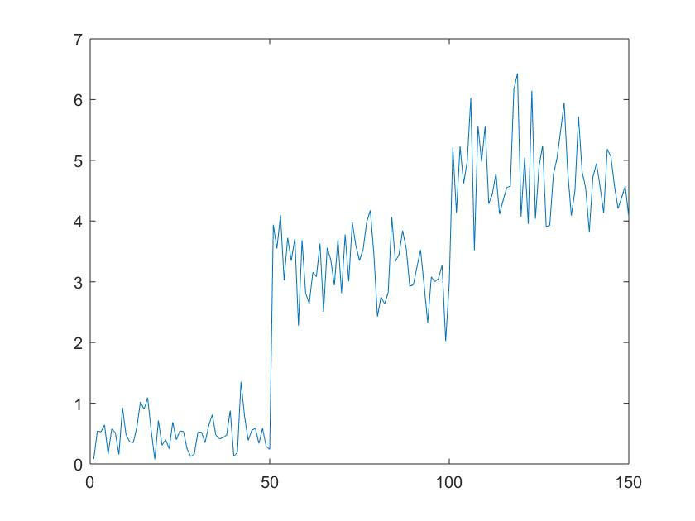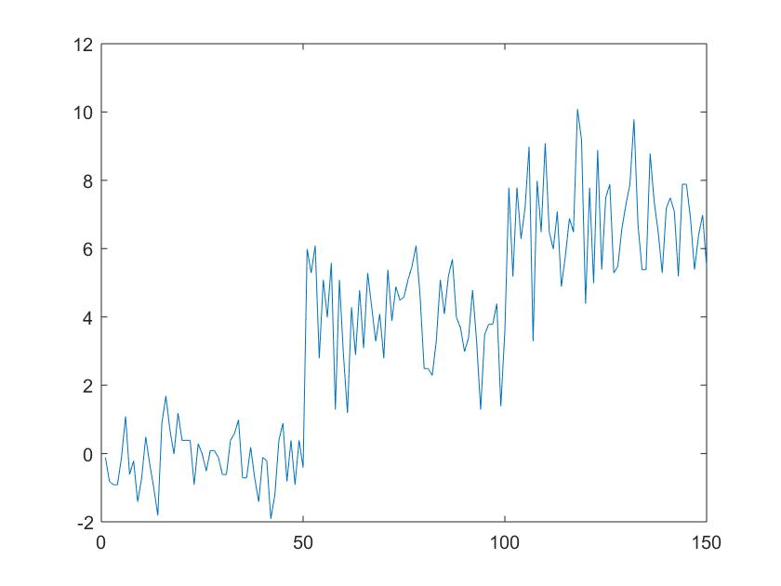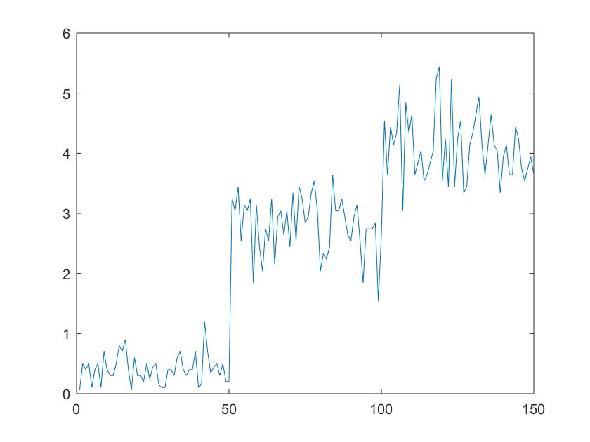

***Minkowoski’s Distance Plots for r=1,2,100***

2) Calculate Mahalanobis distances and plot the obtained distances.

0.1411

1.2960

0.8784

1.2865

0.5829

1.0101

1.2764

0.4351

1.6958

1.0211

0.7723

1.2520

1.1698

1.6127

1.9877

2.0809

1.3032

0.3989

1.2296

0.9741

0.8903

0.6934

1.1127

0.9822

2.1263

1.1828

0.5542

0.3637

0.6354

1.2573

1.0348

1.5168

2.3307

1.7637

1.0211

1.2438

1.5592

1.0211

1.5644

0.3344

0.5618

3.3943

1.5491

1.3301

1.6898

1.4316

1.5087

1.1533

0.6896

0.5006

2.5393

1.7310

2.3855

2.7313

2.2795

2.6457

1.9911

2.7017

2.3349

2.6308

3.2929

1.8100

3.1707

2.2582

1.8322

2.1848

2.7085

2.4127

3.4087

2.2700

2.6043

1.9797

2.5575

2.7721

2.0307

2.1550

2.6856

2.1660

1.9441

2.0787

2.4244

2.4122

1.9131

2.6838

3.2190

2.2948

2.0859

3.1620

2.1770

2.3770

2.9309

2.1156

2.0970

2.7452

2.2459

2.3810

2.0989

1.8467

2.7160

1.9569

3.6365

2.8618

2.6051

2.9361

2.6916

3.3415

3.9676

3.5233

2.9345

3.0256

2.2691

2.4526

2.4970

3.2072

3.9411

2.9333

2.5452

4.0402

3.6609

3.0143

2.6769

3.1942

3.7580

2.4421

2.5816

3.1715

2.3120

2.2340

2.6056

3.3129

3.2271

3.9827

2.7487

2.5461

4.1419

3.6375

3.3391

2.7844

2.2909

2.5661

3.0151

3.7167

2.8618

2.6544

3.1340

3.3967

2.9630

2.3348

3.2452

2.8407

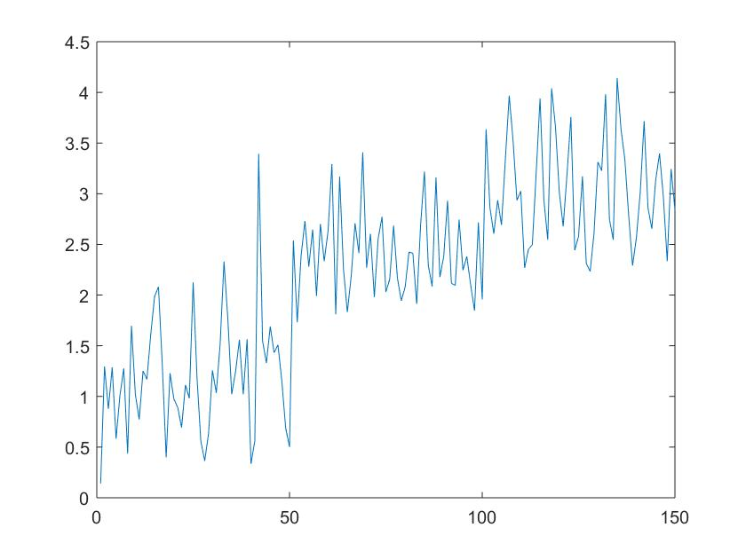

***Plot for Mahalanobis Distance***

5. We provide a dataset with two time series in HW1_DataMining.txt file. Perform the following analysis:

1) Plot the generated two time series in one plot

plot(VarName1,VarName2)

***Plot for time series***

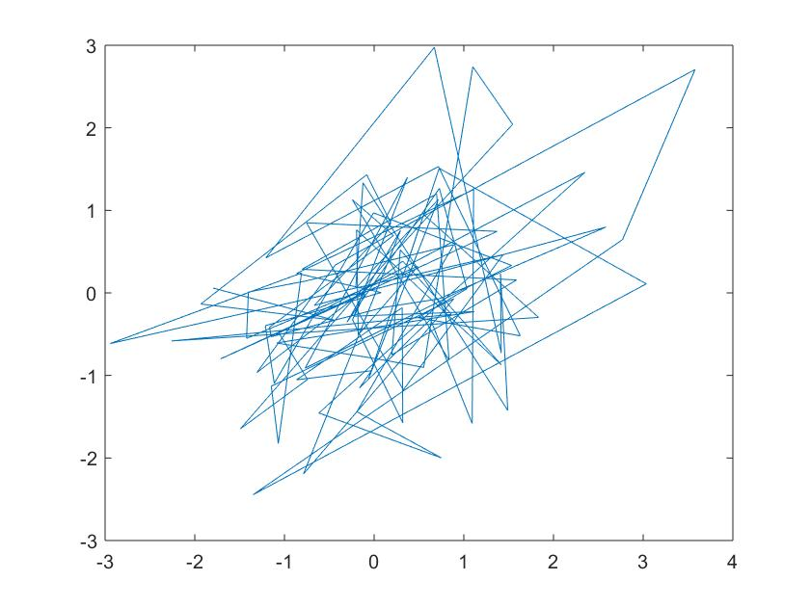

2) Calculate the T-statistics distance between the two time series.

**0.1285**

3) Calculate the correlation of the two time series

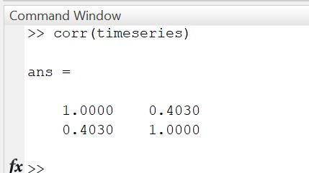

4) Normalize the feature matrix of the IRIS dataset such that after normalization each feature has a mean of 0 and a standard deviation of 1.

Normalizing the data with respect to rows for mean of 0 and standard deviation of 1.

***normalize(a,2);***

1.1700 0.4359 -0.5277 -1.0783

1.2396 0.3068 -0.4787 -1.0678

1.1765 0.4255 -0.5257 -1.0763

1.1766 0.3922 -0.4445 -1.1243

1.1362 0.4869 -0.5333 -1.0898

1.1431 0.4707 -0.5155 -1.0982

1.1233 0.5035 -0.5294 -1.0975

1.1734 0.4148 -0.4859 -1.1023

1.1932 0.3703 -0.4526 -1.1109

1.2084 0.3384 -0.4350 -1.1117

1.1699 0.4333 -0.5199 -1.0832

1.1405 0.4463 -0.4463 -1.1405

1.2180 0.3322 -0.4552 -1.0950

1.1545 0.4645 -0.5441 -1.0749

1.1689 0.4676 -0.6234 -1.0131

1.0944 0.5675 -0.6080 -1.0539

1.1486 0.4984 -0.6285 -1.0185

1.1778 0.4315 -0.5481 -1.0612

1.1921 0.3903 -0.4958 -1.0866

1.1159 0.5177 -0.5407 -1.0929

1.2175 0.3239 -0.4356 -1.1058

1.1437 0.4834 -0.5542 -1.0729

1.0780 0.5989 -0.6468 -1.0301

1.2276 0.3257 -0.4760 -1.0772

1.1254 0.4173 -0.3414 -1.2012

1.2448 0.2685 -0.4149 -1.0983

1.1882 0.3961 -0.4951 -1.0892

1.1810 0.4088 -0.4997 -1.0902

1.2017 0.3854 -0.5215 -1.0656

1.1667 0.3974 -0.4231 -1.1410

1.2012 0.3414 -0.4173 -1.1254

1.2392 0.3297 -0.5343 -1.0345

1.0583 0.5880 -0.5238 -1.1225

1.0931 0.5618 -0.5823 -1.0726

1.2084 0.3384 -0.4350 -1.1117

1.2176 0.3746 -0.5620 -1.0302

1.2197 0.3712 -0.5621 -1.0288

1.2084 0.3384 -0.4350 -1.1117

1.1745 0.4185 -0.4995 -1.0935

1.1868 0.3956 -0.4887 -1.0937

1.1655 0.4592 -0.5769 -1.0478

1.3361 0.1113 -0.4454 -1.0021

1.1290 0.4915 -0.5180 -1.1025

1.1851 0.4205 -0.5479 -1.0576

1.1109 0.4830 -0.4347 -1.1592

1.2371 0.3188 -0.4974 -1.0585

1.1058 0.5130 -0.4902 -1.1286

1.1588 0.4378 -0.4893 -1.1073

1.1568 0.4517 -0.5178 -1.0907

1.1953 0.3905 -0.5089 -1.0769

1.2336 -0.3690 0.2636 -1.1281

1.2075 -0.3381 0.2898 -1.1592

1.2034 -0.4298 0.3438 -1.1175

1.1992 -0.5255 0.3908 -1.0645

1.2176 -0.4825 0.3446 -1.0798

1.1024 -0.4020 0.4799 -1.1802

1.1612 -0.3371 0.3621 -1.1861

1.2232 -0.3058 0.2446 -1.1621

1.2087 -0.4175 0.3296 -1.1208

1.1679 -0.3688 0.3688 -1.1679

1.2143 -0.5000 0.3571 -1.0714

1.2079 -0.3489 0.2953 -1.1542

1.2375 -0.5042 0.3208 -1.0542

1.1315 -0.4258 0.4501 -1.1558

1.2624 -0.2525 0.1403 -1.1502

1.2530 -0.3580 0.2238 -1.1188

1.0918 -0.3639 0.4759 -1.2038

1.1758 -0.3429 0.3429 -1.1758

1.2062 -0.6495 0.4175 -0.9742

1.2072 -0.4024 0.3245 -1.1293

1.0979 -0.4030 0.4864 -1.1813

1.2578 -0.3699 0.2220 -1.1098

1.1395 -0.5925 0.5014 -1.0483

1.1182 -0.4193 0.4659 -1.1648

1.2362 -0.3813 0.2657 -1.1207

1.2470 -0.3854 0.2494 -1.1110

1.2090 -0.4879 0.3606 -1.0818

1.1810 -0.4997 0.4088 -1.0902

1.1667 -0.4231 0.3974 -1.1410

1.2747 -0.3059 0.1530 -1.1217

1.2179 -0.4236 0.3177 -1.1120

1.2267 -0.3915 0.2871 -1.1223

1.2344 -0.3600 0.2572 -1.1316

1.0503 -0.5618 0.6107 -1.0992

1.0498 -0.3499 0.5249 -1.2247

1.1464 -0.2563 0.3372 -1.2273

1.2140 -0.4047 0.3147 -1.1240

1.2224 -0.5720 0.3701 -1.0206

1.1584 -0.2758 0.3310 -1.2135

1.1932 -0.4526 0.3703 -1.1109

1.0892 -0.4331 0.5118 -1.1680

1.1470 -0.3823 0.4070 -1.1716

1.2205 -0.4068 0.3051 -1.1188

1.2447 -0.3556 0.2371 -1.1261

1.1564 -0.4034 0.4034 -1.1564

1.1428 -0.2758 0.3546 -1.2216

1.1611 -0.3336 0.3603 -1.1878

1.2126 -0.3722 0.3002 -1.1406

1.3118 -0.2563 0.0452 -1.1007

1.1878 -0.3603 0.3336 -1.1611

0.9300 -0.6419 0.7728 -1.0610

1.0296 -0.6284 0.6552 -1.0563

1.0905 -0.6458 0.5823 -1.0270

1.0021 -0.5826 0.6758 -1.0953

1.0143 -0.6563 0.6802 -1.0382

1.0340 -0.6800 0.6614 -1.0154

0.9709 -0.5826 0.7120 -1.1004

1.0322 -0.6345 0.6534 -1.0512

1.0363 -0.7047 0.6632 -0.9948

1.0813 -0.5752 0.5752 -1.0813

1.1529 -0.5013 0.4511 -1.1028

1.0949 -0.6475 0.5769 -1.0243

1.1257 -0.6203 0.5284 -1.0338

1.0417 -0.7128 0.6579 -0.9869

1.0578 -0.7300 0.6406 -0.9684

1.1161 -0.5846 0.5315 -1.0630

1.0579 -0.5520 0.5980 -1.1039

1.0219 -0.5110 0.6289 -1.1398

1.0011 -0.8062 0.7176 -0.9125

1.0737 -0.6812 0.6119 -1.0044

1.1103 -0.6194 0.5493 -1.0401

1.0431 -0.6023 0.6317 -1.0724

1.0283 -0.7092 0.6737 -0.9928

1.1585 -0.5976 0.4756 -1.0366

1.0618 -0.5427 0.5899 -1.1090

1.0668 -0.5435 0.5837 -1.1071

1.1637 -0.5565 0.4553 -1.0625

1.1203 -0.4950 0.4950 -1.1203

1.0382 -0.6802 0.6563 -1.0143

1.0954 -0.5477 0.5477 -1.0954

1.0873 -0.6677 0.5914 -1.0110

1.0917 -0.4651 0.5221 -1.1486

1.0429 -0.7034 0.6548 -0.9944

1.0929 -0.5177 0.5407 -1.1159

0.9517 -0.5798 0.7330 -1.1049

1.1447 -0.6947 0.5185 -0.9686

1.0245 -0.5601 0.6421 -1.1065

1.0371 -0.5185 0.6128 -1.1314

1.1257 -0.4825 0.4825 -1.1257

1.1595 -0.5855 0.4707 -1.0447

1.1063 -0.6638 0.5654 -1.0079

1.2331 -0.6044 0.3627 -0.9913

1.0296 -0.6284 0.6552 -1.0563

1.0502 -0.6301 0.6301 -1.0502

1.0882 -0.6327 0.5821 -1.0376

1.1872 -0.6431 0.4452 -0.9893

1.1441 -0.6865 0.5179 -0.9755

1.1359 -0.5741 0.5008 -1.0627

1.0467 -0.5164 0.6001 -1.1304

1.0350 -0.5042 0.6104 -1.1411